FOR MORE INFORMATION:
Annie Miller
BRAVE Public Relations
404.233.3993
amiller@emailbrave.com

Riverdance 25th Anniversary Show to play the Fox Theatre, Jan. 27-29
Tickets go on Sale, Nov. 17
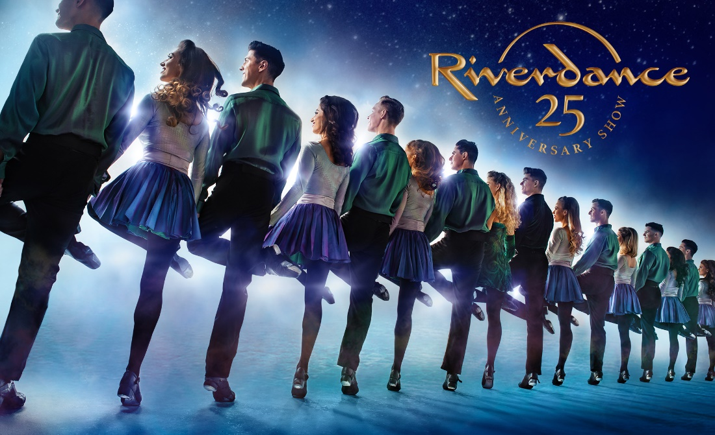

ATLANTA (Nov. 11, 2022)- Regions Bank Broadway in Atlanta announced today that the individual tickets for the tour of Riverdance 25th Anniversary Show will go on sale Nov. 17. Tickets will be available at the Fox Theatre box office (660 Peachtree Street NE, Atlanta, Georgia 30308), by visiting foxtheatre.org/Riverdance or by calling (855)-285-8499. Group orders of 10 or more may be placed by calling the Fox Theatre at (855)-285-8499.

Playing as a special to Regions Bank Broadway in Atlanta’s 2022/2023 season, the Atlanta engagement of Riverdance 25th Anniversary Show will play Jan. 27—29. The performance schedule is as follows:
Friday 8 p.m.
Saturday 2 p.m., 8 p.m.
Sunday 1 p.m., 6:30 p.m.

Riverdance 25th Anniversary Show is Riverdance, as you’ve never seen it before! A powerful and stirring reinvention of this beloved favorite, celebrated the world over for its Grammy Award-winning score and the thrilling energy and passion of its Irish and international dance. Composer Bill Whelan has rerecorded his mesmerizing soundtrack while producer Moya Doherty and director John McColgan have completely reimagined the ground-breaking show with innovative and spectacular lighting, video, stage and costume designs.

Immerse yourself in the extraordinary power and grace of its music and dance–beloved by fans of all ages. Fall in love with the magic of Riverdance all over again.

The 25th anniversary production of Riverdance is continuing its critically acclaimed tour in over 50 cities across North America in 2023. Riverdance completed a successful 40-city North American Tour yesterday, which marked the dance phenomenon’s long-awaited return to stages after the COVID-19 pandemic shutdown. The 2022 tour included a sold-out, two-week inaugural run at Washington DC’s historic Kennedy Center, a special performance for President Joe Biden and Speaker of the House Nancy Pelosi and national television appearances on The Tonight Show starring Jimmy Fallon, Good Morning America, GMA3 and Watch What Happens Live. The 2023 Tour recently kicked off with a special performance on America’s Got Talent, seen by over 7 million people across the country.

The critically acclaimed 25th Anniversary North American Tour was shut down in March 2020 during a sold-out return engagement to New York City’s Radio City Music Hall due to the COVID-19 pandemic. In 2021, Riverdance celebrated a return to the stage in the United Kingdom, where the iconic show played to sold out audiences in 27 cities across the country. Then followed its debut at Expo 2020 Dubai with a special production of Riverdance presenting a multi-cultural experience including artists from the Middle East region. A highlight of the four-week run was the Riverdance performance at the USA Pavilion at Expo 2020 Dubai for their Thanksgiving Day celebrations.

Riverdance The Animated Adventure was released on Netflix in the United States on January 14, 2022, where it swiftly landed a spot on the streamer’s Global Top 10 list. With an original score by Grammy Award-winning composer Bill Whelan, the animated musical comedy features the incredible craft and skill of the Riverdance troupe by utilizing motion capture of their performances to create the animated dancing in the film. Tour lead dancers Maggie Darlington and Anna Mai Fitzpatrick and Executive Producer/Director Padraic Moyles were involved with the dance production for the film, while tour musicians Mark Alfred and Tara Howley play on the film score.

Riverdance began its journey as the interval act in the 1994 Eurovision Song Contest, produced for television by Moya Doherty. This electrifying and innovative seven-minute dance piece was then developed into a full-length stage show by Producer Moya Doherty, Composer Bill Whelan and Director John McColgan. With its fusion of Irish and International music and dance, the show broke all box office records during its world première run in Dublin in early 1995. When the show transferred to London the reaction was unprecedented. There followed a hugely successful tour starting in New York in March 1996, where 8 sold-out shows at Radio City Music Hall heralded the start of more than two decades of touring by Riverdance companies throughout North America. Since its inception, Riverdance has packed theatres throughout North America, Oceania, Asia, Europe, South Africa and South America.

Riverdance 25th Anniversary Show has been designed by lead designer Peter Canning, featuring Set by Alan Farquharson, Lighting by Andrew Voller and Video by Cosmo AV along with Costumes by Joan Bergin and Sound by Michael O’Gorman.

For more information, please visit:
Website: www.riverdance.com
Facebook: @Riverdance
Twitter: @Riverdance
Instagram: @Riverdance
TikTok: @Riverdance25
###

ABOUT BROADWAY ACROSS AMERICA
Broadway Across America (BAA) is part of the John Gore Organization family of companies, which includes Broadway.com, The Broadway Channel, BroadwayBox.com, Group Sales Box Office and Broadway Brands. Led by 18-time Tony-winning theater producer John Gore (Owner & CEO), BAA is the foremost presenter of first-class touring productions in North America, operating in 48 markets with over 400,000 subscribers. Presentations include Disney’s The Lion King, Wicked, The Book of Mormon

